Test Cases

|  |  |  |  |  |  |  |  |
| --- | --- | --- | --- | --- | --- | --- | --- |
| Serial Number | Test case description | Entry criteria | Exit criteria | Expected result | Actual result | Test date | Test pass/fail |
| 1 | Test if home page loads | URL for home page | Home page loaded | Loaded home page | Loaded home page | 24/10/17 | Pass |
| 2 | Test if the login button on the homepage links to the login page correctly | URL for login page | Login page loaded | Loaded login page | Loaded login page | 24/10/17 | Pass |
| 3 | Test if register button on the login page links to the home page for the user type | URL for user type home page | User type home page loaded | Loaded user type home page | Loaded user type home page | 24/10/17 | Pass |
| 4 | Test if the login button on the login page links to the home page for the user type | URL for the user type home page | User type home page loaded | Loaded user type home page | Loaded user type home page | 24/10/17 | Pass |
| 5 | Test if the home page button on the login page links back to the home page | URL for the homepage | Home page loaded | Loaded home page | Loaded home page | 24/10/17 | Pass |
| 6 | Test if when a user logs in it registers in the database | Login page | Time stamp and data in database for login | Data in database | Data registered in the database | 24/10/17 | Pass |
| 7 | Test if the homepage button on the student user type home page links back to the website home page | URL for home page | Home page loaded | Loaded home page | Loaded home page | 24/10/17 | Pass |
| 8 | Test if the home page button on the tourist user type home page links back to the website home page | URL for homepage | Home page loaded | Loaded home page | Loaded home page | 24/10/17 | Pass |
| 9 | Test if the home page button on the businessman user type home page links back to the website home page | URL for homepage | Home paged loaded | Loaded home page | Loaded home page | 24/10/17 | Pass |
| 10 | Test if the text boxes on the login/register page can be inputted into by the user | Loading login page | Text boxes containing text that has been inputted into them | Text boxes allowing text to be inputted | Text boxes allowed text to be inputted | 24/10/17 | Pass |
| 11 | Test if the drop down box on the login/register page can be used to select the user type by the user | Loading login page | Drop down box with a user type selected | Drop down box allowing the user to select a user type | Drop down box allowed the user to select a user type | 24/10/17 | Pass |
| 12 | Test if the home pages change information based on the user type | Loading user type home pages | Each home page displaying the correct information for the user type | Each page displaying the correct information | Each page displayed the correct information for the user type | 24/10/17 | Pass |
| 13 | Test if the search bar is functional on the user type specific home pages | Loading user type home pages and attempting to type in the search bar | The search bar on each home page is functional | The search bar on each home page allow text to be entered into them | The search bar on each home page was functional as it allowed text to be entered into it | 24/10/17 | Pass |
| 14 | Test if all text boxes on the login/register page that users are inputting passwords into are hiding the characters correctly | Loading the login/register page and entering a password in both the password text boxes | Text boxes hiding characters | Both text boxes will hide the characters correctly | Both text boxes successfully hid the characters | 24/10/17 | Pass |

# Test Evidence Serial 1 - The home page loaded correctly



# Test Evidence Serial 2 – Selecting the login button on the home page



# The login page loaded correctly after pressing the login button

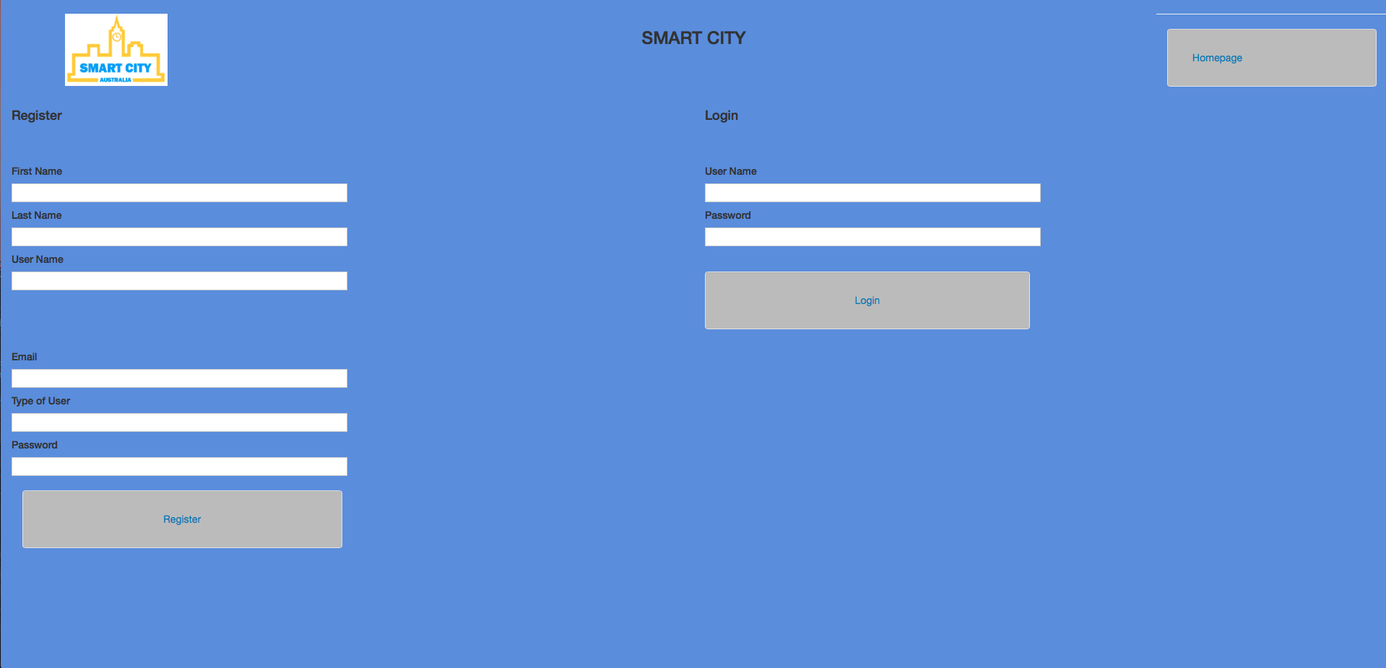

# Test Evidence Serial 3 – Selecting the Register button on the login/register page

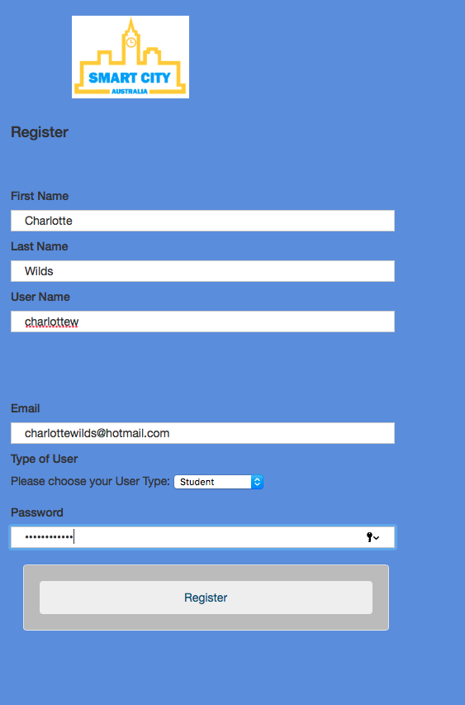

# The user type home page loaded correctly

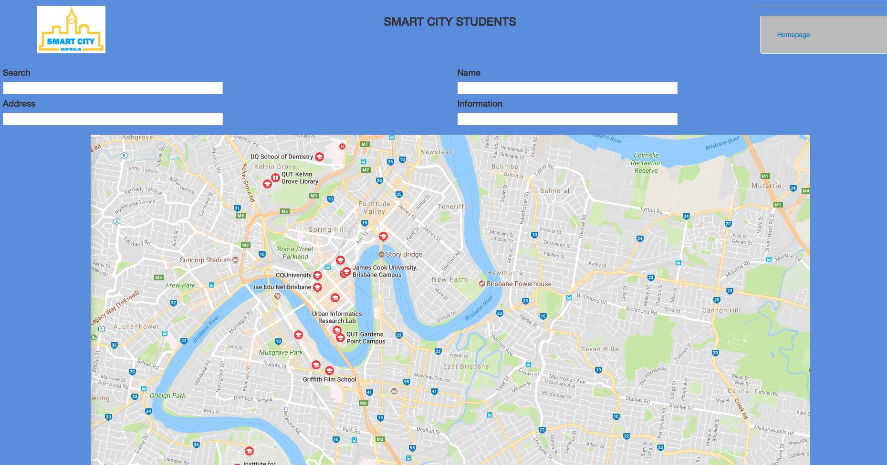

# Test Evidence Serial 4 – Selecting the login button on the login/register page

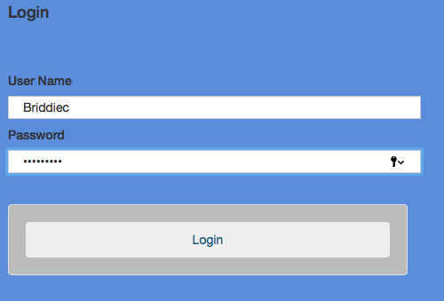

# The home page for the user type loaded correctly



# Test Evidence Serial 5 – Selecting the home page button on the login/register page

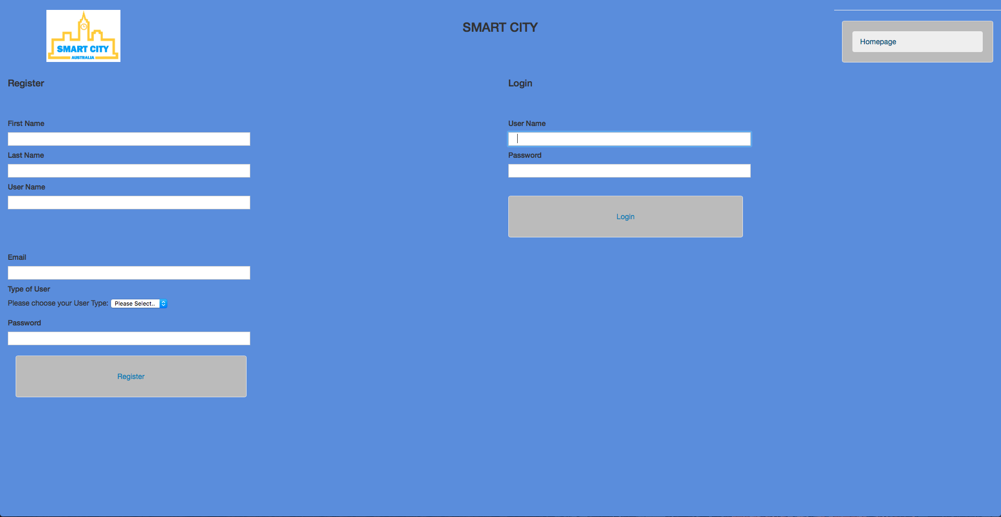

# The home page loaded correctly



# Test Evidence Serial 6 – If a user logs in it registers in the database

This is a user that has been registered into the database

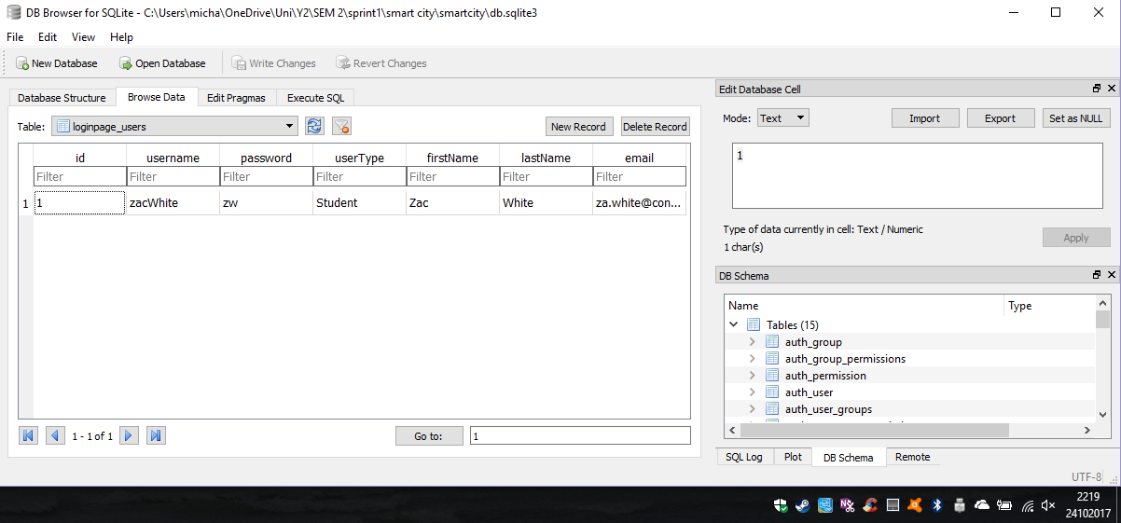

This is the last time that this user logged into the website which was registered in the database

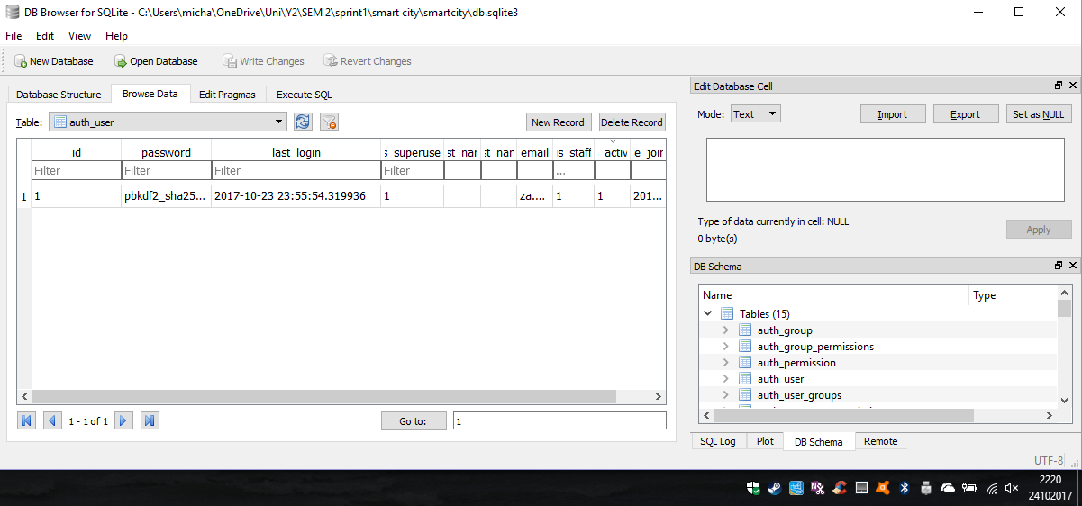

This is the user logging into the website

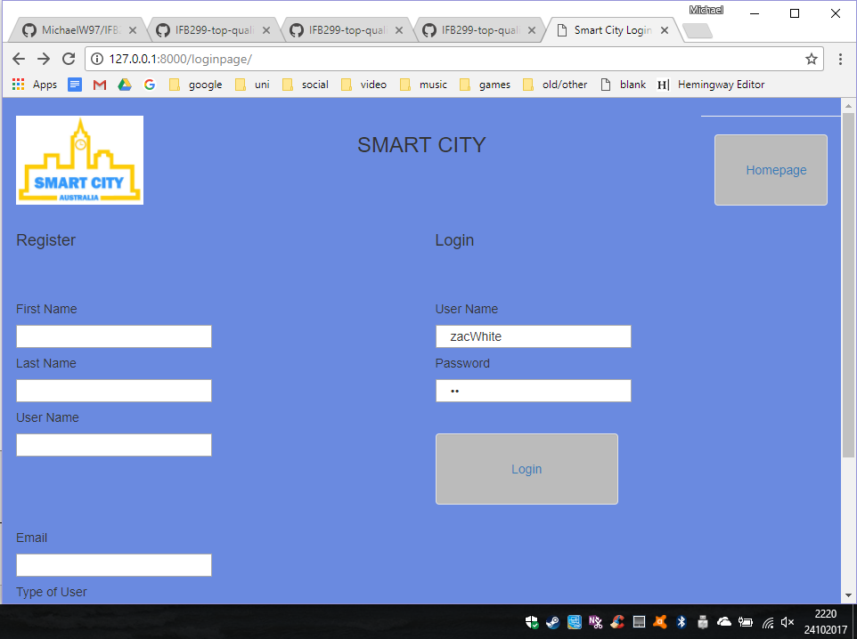

The user has successfully logged into the website and has reached the user type specific home page

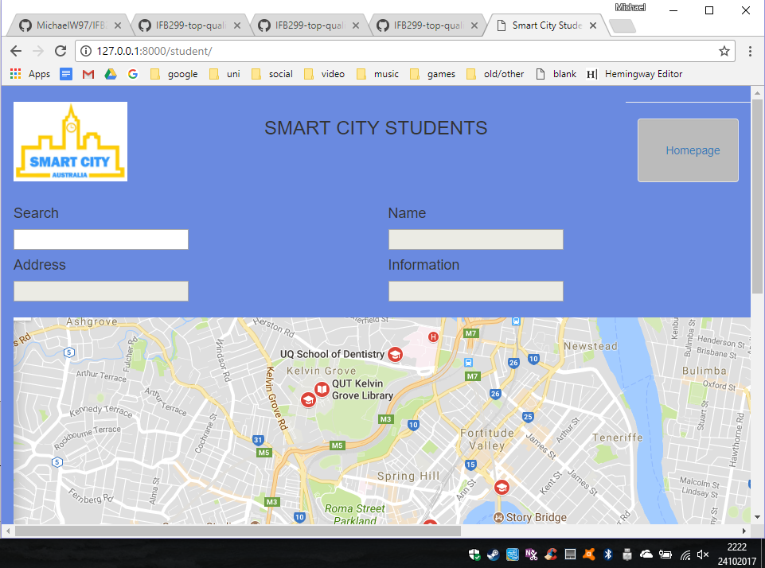

The database has now been updated with the users most recent log in

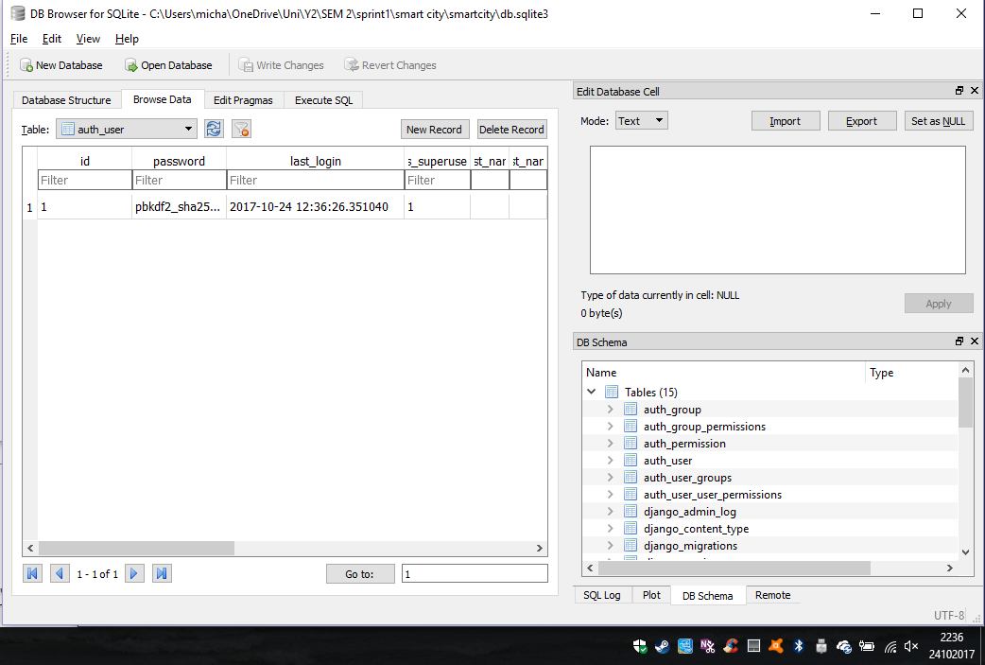

# Test Evidence Serial 7 – Selecting the home page button on the student home page

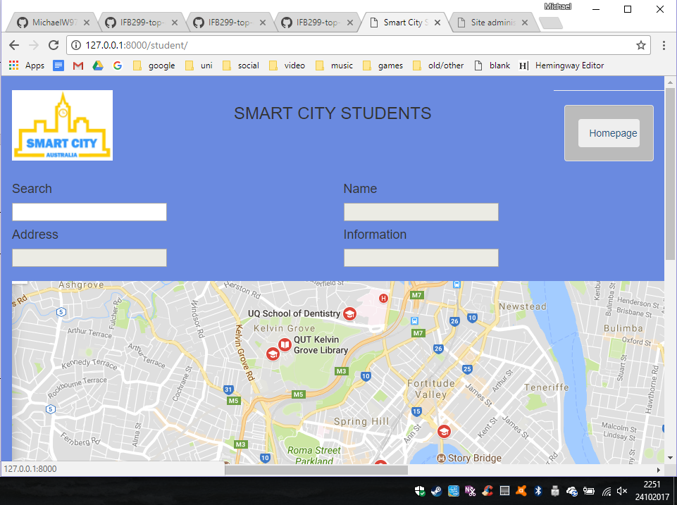

# Home page loaded correctly



# Test Evidence Serial 8 – Selecting the home page button on the tourist home page

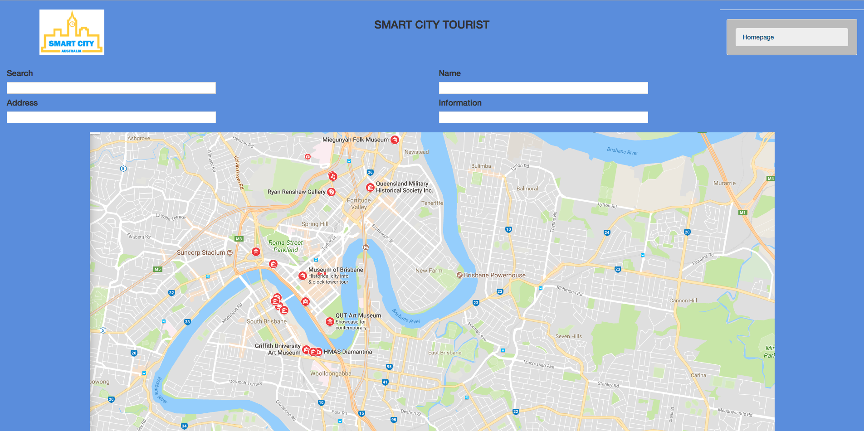

# Home page loaded correctly



# Test Evidence Serial 9 – Selecting the home page button on the business home page

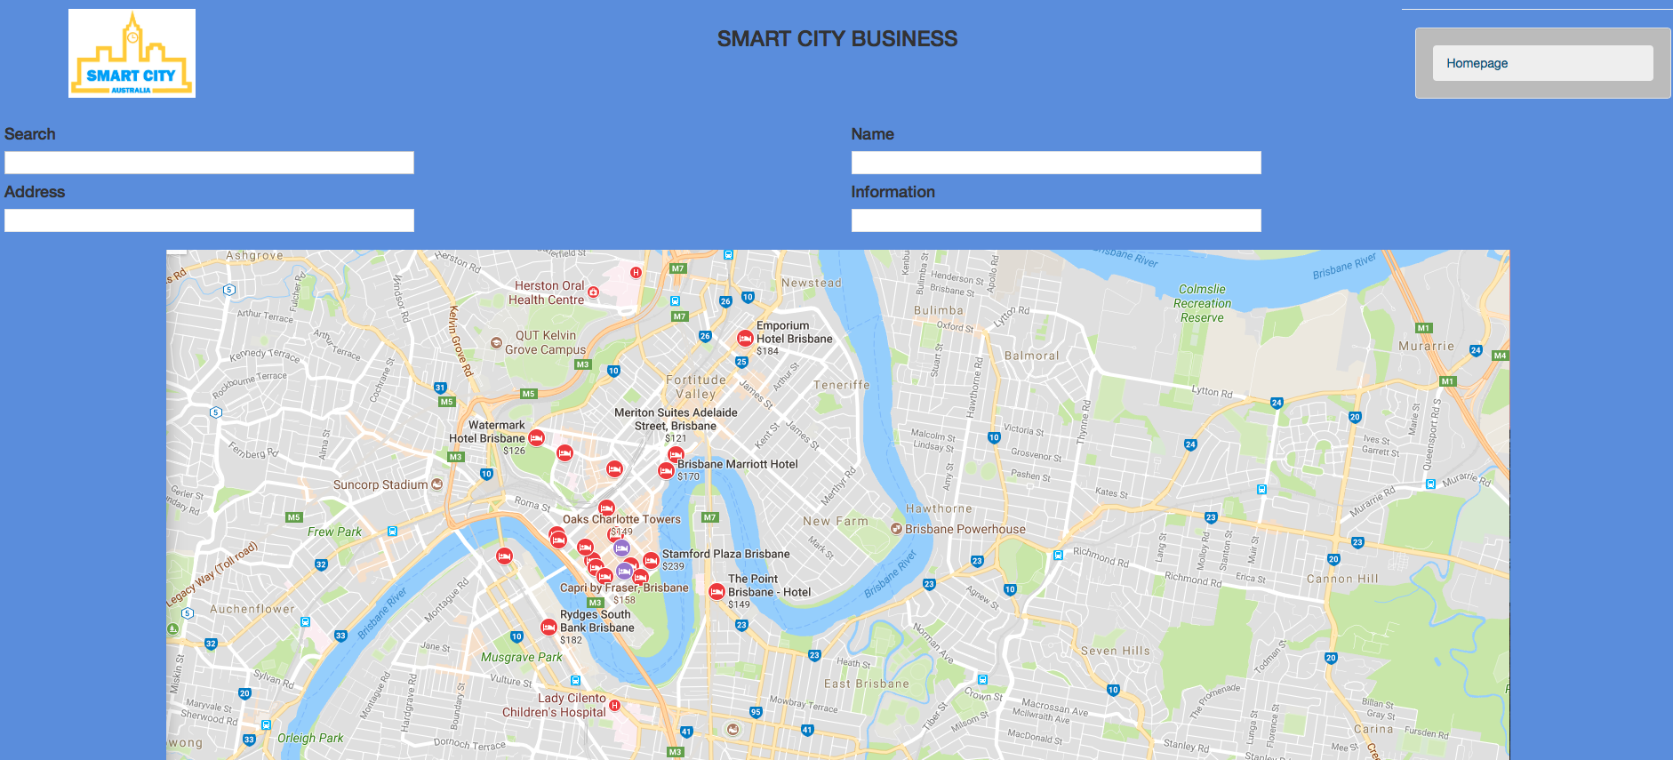

# The home page loaded correctly



# Test Evidence Serial 10 – Testing if text boxes on the login/register page can be inputted by the user

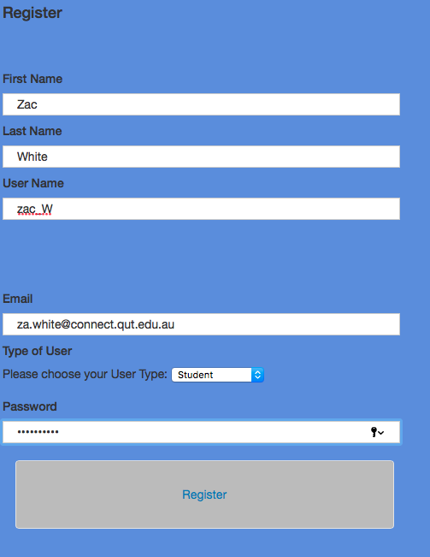

# Test Evidence Serial 11 - Test if the drop down box on the login/register page can be used to select the user type by the user

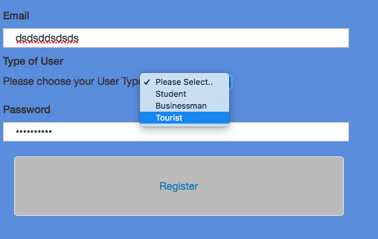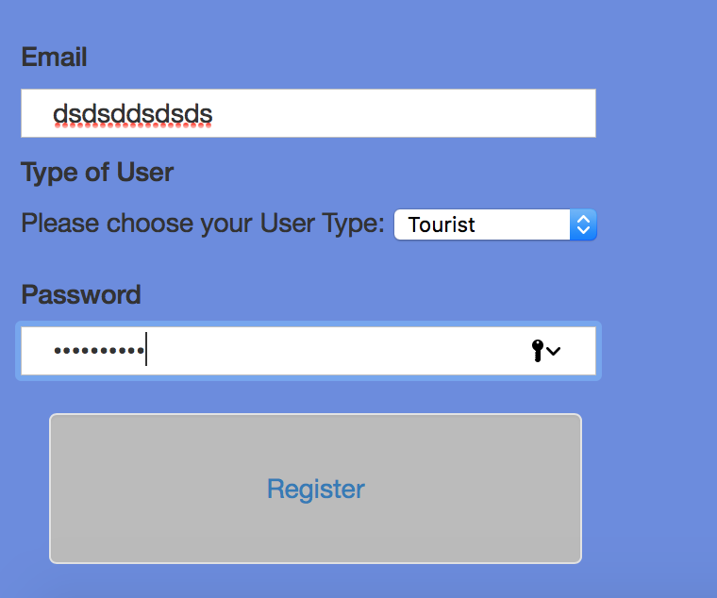

# Test Evidence Serial 12 - Test if the home pages’ change information based on the user type

Home page for tourist user type

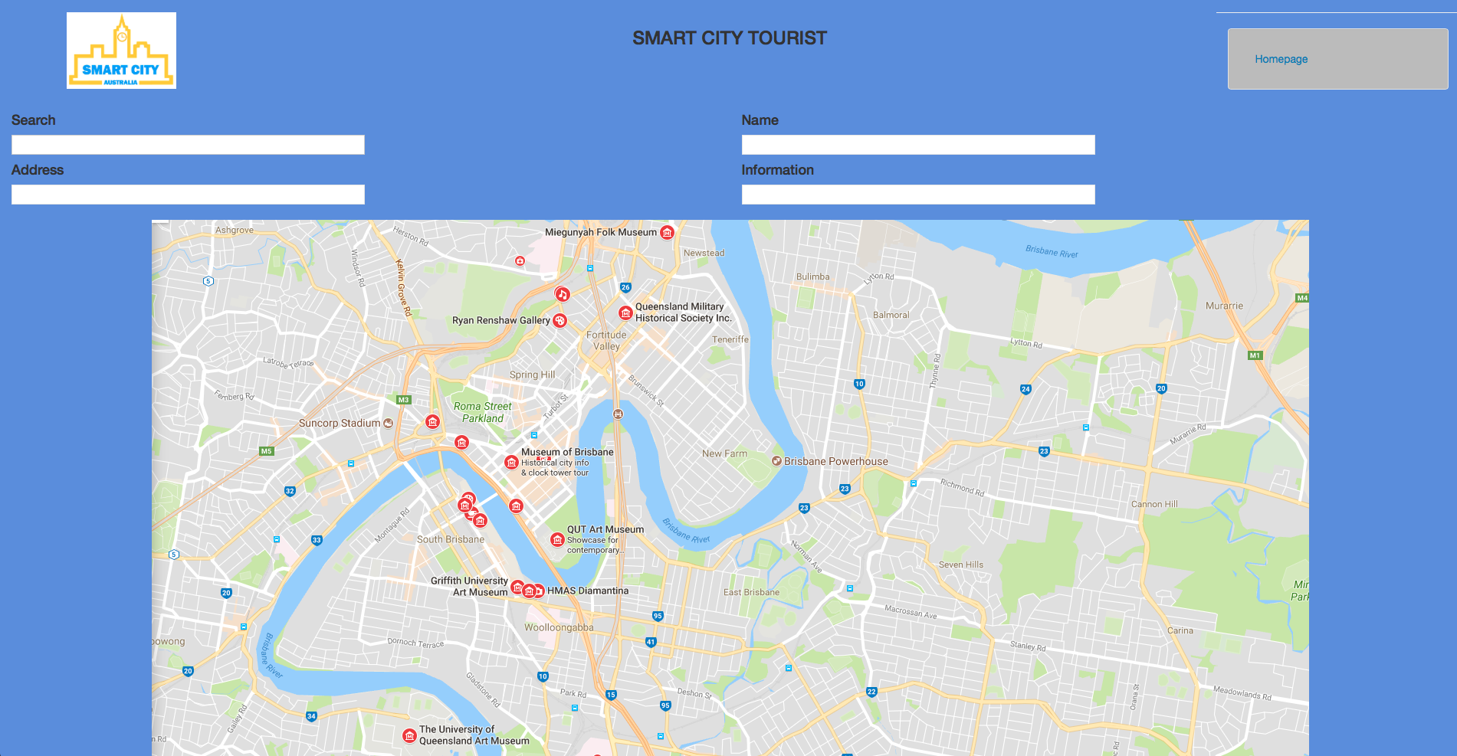

Home page for student user type

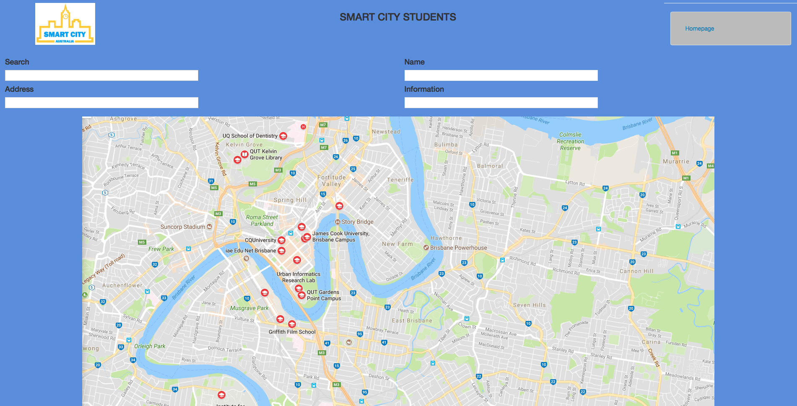

Home page for business user type

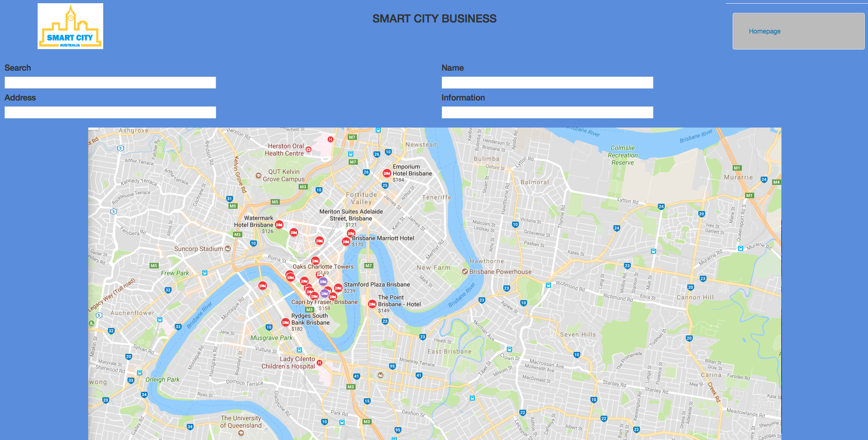

# Test Evidence Serial 13 - Test if the search bar is functional on the user type specific home pages

The Tourist home page with functioning search bar

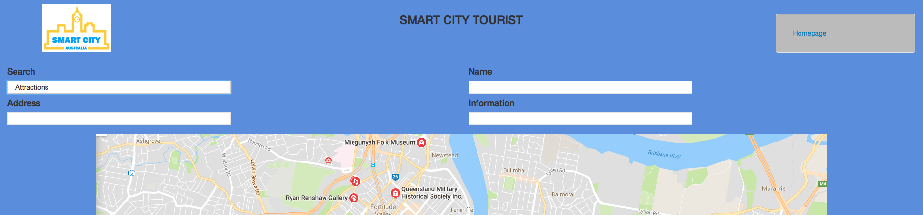

The Student home page with function search bar

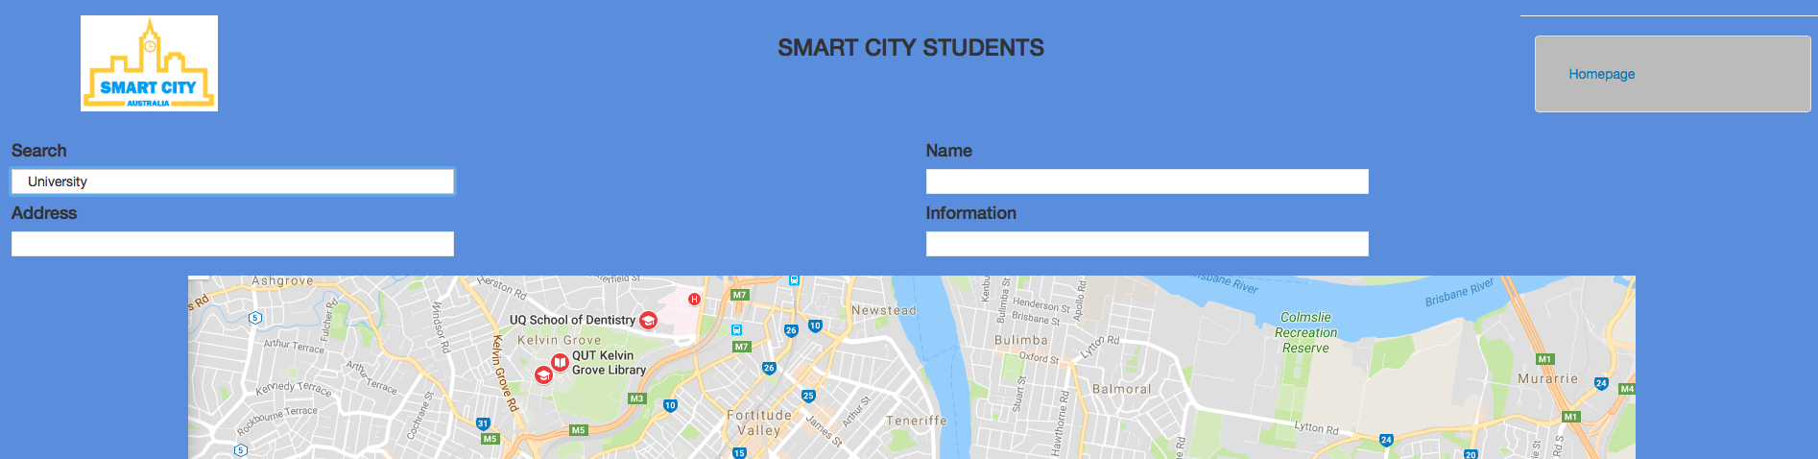

The business home page with functional search bar

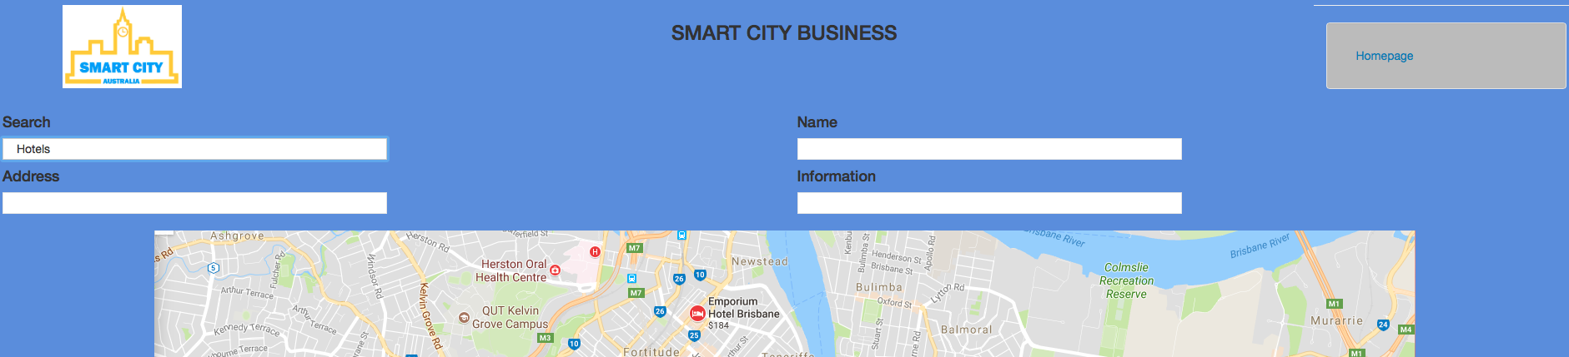

# Test Evidence Serial 14 - Test if all text boxes on the login/register page that users are inputting passwords into are hiding the characters correctly

